**Nininger Township**

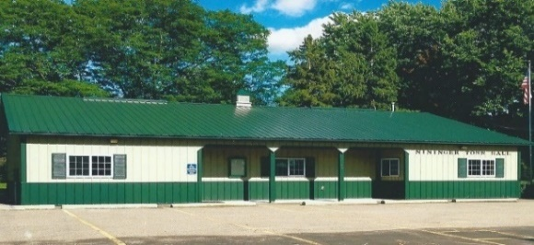 **Dakota County, Minnesota**

**Board of Supervisors**

**Agenda**

**September 17, 2024, 7 PM**

12390 Ivanhoe Way

Hastings, MN 55033

**Agenda**

1. **Motion to close August 20, 2024 meeting**
2. **Meeting called to order- Bob Rotty**
3. **Pledge of Allegiance**
4. **Approve Agenda**
5. **Approve Minutes of Board of Supervisors** –August 20, 2024 meeting
6. **Treasurer’s Report----**Janet Bremer
7. **Building Permits---**Bob Rotty

**a.**

1. **Public Comment:** Visitors may share their concerns with the Town Board on any issue.
   1. Dakota County’s [Agriculture Chemical Reduction Effort](https://linkprotect.cudasvc.com/url?a=https%3a%2f%2fwww.co.dakota.mn.us%2fEnvironment%2fWaterResources%2fAgriculture%2fDocuments%2fACREPlan.pdf&c=E,1,pYmtOvV_qAebSiTlGOtSPA4XxWzVSyqtTViKwilEj7KP4z3K8nSmfIKvr8PSN0yZvUeZq0jnjFcDKEaGOABpGyld2oKtZufAsm9NbNZ_-sS4aaQINZfDNg,,&typo=1) (ACRE)-Matthew Belanger
2. **Road & Bridges Report**---Bob Rotty

1. **Fire Report---**David Bauer
2. To**wn Hall Maintenance/Correspondence**--Karen Bremer
3. **Old Business**
   1. **PFAS update**-David.
   2. **Pine Bend Trail Project**
   3. **Furlong Trail Project**
   4. **Town Hall Entryway project**
   5. **Cannabis Legislation**
4. **New Business**
   1. **2050 Regional Development Guide Public Comment Period-**

August 15-October 7, 2024-Information attached.

* 1. **Joint Powers Agreement Between Township of Nininger and the County of Dakota for Enforcement of Local Ordinances-**Expires December 31, 2024-needs renewal.

1. **Approve and sign bills**.
2. **Next meetings: Planning Commission Meeting**-Monday, October 1, 2024, 8 PM

**Board of Supervisors Meeting**-Tuesday, October 15, 2024, 7 pm

1. **Adjournment**