**Nininger Township**

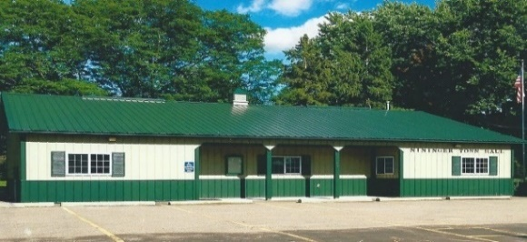 **Dakota County, Minnesota**

**Board of Supervisors**

**Agenda**

**August 20, 2024**

12390 Ivanhoe Way

Hastings, MN

**Agenda**

1. **Meeting called to order -Bob Rotty**
2. **Pledge of Allegiance**
3. **Approve Agenda**
4. **Approve Minutes of Board of Supervisors** –July 16, 2024 meeting
5. **Treasurer’s Report----**Janet Bremer
6. **Building Permits---**Bob Rotty----Jake Gerl, 15825 Frame Ave, Hastings, MN 1500 square foot pole barn.
7. **Public Comment:** Visitors may share their concerns with the Town Board on any issue.
8. **Road & Bridges Report**---Bob Rotty
9. **Fire Report---**David Bauer-.
10. To**wn Hall Maintenance/Correspondence**--Karen Bremer
11. **Old Business**
    1. **PFAS update**-David-
    2. **Motion to approve closing of Pine Bend Trail**
    3. **Furlong Trail Project**
    4. **Town Hall Entryway Project Update**
12. **New Business**
    1. **3M Cottage Grove wastewater permit meeting invite**
13. **Approve and sign bills**.
14. **Next meetings:** Planning Commission-Monday, September 9, 2024-8 PM

Board of Supervisors-Tuesday, September 17, 2024, 7 pm

1. **Adjourn**