Nininger Township
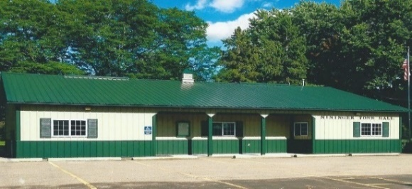
Dakota County, Minnesota
Board of Supervisors
Agenda
July 16, 2024, 7 PM
12390 Ivanhoe Way
Hastings, MN 55033
Agenda
- Motion to close June 18, 2024 meeting
- Meeting called to order- Bob Rotty
- Pledge of Allegiance
- Approve Agenda
- Approve Minutes of Board of Supervisors –June 18, 2024 meeting
- Treasurer’s Report----Janet Bremer
- Building Permits---Bob Rotty
  - Jake Gerl, 15825 Frame Avenue, Hastings, MN, 1500-square-foot pole barn
- Public Comment: Visitors may share their concerns with the Town Board on any issue.
  - Sue Vento-MET Council-PFAS
- Road & Bridges Report---Bob Rotty

- Fire Report---David Bauer

- Town Hall Maintenance/Correspondence--Karen Bremer

- Old Business
  - PFAS update-David.
  - Pine Bend Trail Project
  - Furlong Trail Project
  - Nininger Twp - 3rd Quarter Update-Dakota County-Information only

- New Business
  - Resolution to appoint election judges for Primary election-August 13, 2024 and General Election, November 5, 2024

- Approve and sign bills.

- Next meetings: Planning Commission Meeting-Monday, August 5, 2024, 8 PM
Public Information Meeting-Furlong Trail-Monday August 5, 2024, 8 PM
Primary Election-Tuesday, August 13, 2024, 7am-8pm
Board of Supervisors Meeting-Tuesday, August 20, 2024, 7 pm
- Adjournment

