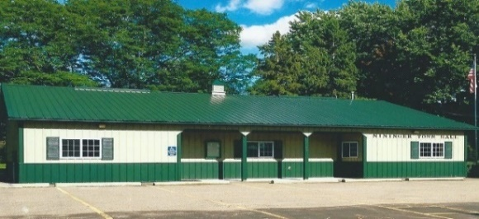
Nininger Township
Dakota County, Minnesota
Board of Supervisors
Agenda
December 19, 2023
12390 Ivanhoe Way
Hastings, MN 55033
Agenda
- Meeting called to order.
- Pledge of Allegiance
- Approve Agenda
- Approve Minutes of Board of Supervisors –November 21, 2023 meeting

- Treasurer’s Report----Janet Bremer

- Building Permits---Bob Rotty

- Public Comment: Visitors may share their concerns with the Town Board on any issue.
  - Travis Thiele--The Vermillion River Watershed Joint Powers Organization (VRWJPO)

- Planning Commission Report-Bob Rotty

- Road & Bridges Report---Bob Rotty

- Fire Report----David Bauer

- Town Hall Maintenance/Correspondence--Karen Bremer

- Old Business
  - Dakota County and Nininger Township plan to paving Pind Bend Trail and Furlong Trail Updates.
  - PFAS update-David
- New Business

- Approve and sign bills.

- Next meeting: Tuesday, January 16, 2024, 7 pm

- Adjourn

