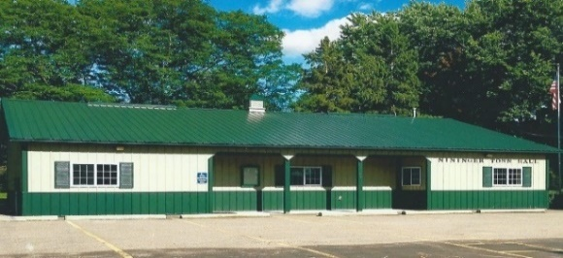
Nininger Township
Dakota County, Minnesota
Board of Supervisors
Agenda
November 21, 2023
12390 Ivanhoe Way
Hastings, MN 55033
Agenda
- Meeting called to order.
- Pledge of Allegiance
- Approve Agenda
- Approve Minutes of Board of Supervisors –October 17, 2023 meeting

- Treasurer’s Report----Janet Bremer

- Building Permits---Bob Rotty

- Public Comment: Visitors may share their concerns with the Town Board on any issue.

- Planning Commission Report-Bob Rotty

- Road & Bridges Report---Bob Rotty

- Fire Report----David Baue

- Town Hall Maintenance/Correspondence--Karen Bremer

- Old Business
  - Dakota County and Nininger Township plan to paving Pind Bend Trail and Furlong Trail Updates
- New Business
  - Mississippi River Corridor Critical Area (MRCCA) Model Ordinance
  - Xcel Energy new Minnesota Transportation Electrification Plan
  - Dakota County Regional Railroad Authority draft of 2024-2028 Capital Improvement Program (CIP)
  - Invitation: 2023 Annual Meeting of the MN Association of Townships December 7-9 in St. Cloud
- Approve and sign bills.

- Next meeting: Tuesday, December 19, 2023, 7 pm/Christmas Party

- Adjourn

